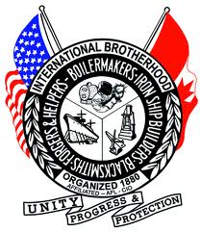
Boilermakers Local Lodge 85 –Apprentice Periods & Rates
Effective June 1, 2016

8thPeriod (85%)
Nick Babcock Kiel Fisher Kyle Metzger Jason Sprouse
Caleb Rowe Ryan Schroeder John M. Shiple Miles Tullos

6th Period (80%)
Josh Barbour John K. Miller Nick Burns Zach Thayer Justin Fountain David Graham Nicholas Platt Joshua Haugh Timothy Rugg Brandon Jacobs Steven Leck Julie Smith Richard Spafford Scott McDonald Justin Stager

4th Period (77.5%)
Lyndon Coutcher Christopher Siwajek Todd Thober John Jennings Joshua Monhollen Jeremy Watkins Jesus Contreras

2nd Period (72.5%)
Thomas Brillhart Stephen Brown Michael Brown Jane-L Timmons
Corey Durbin Troy Green Kristen Griffin Jordan Grodi
Tyler Koester Derek Partin Travis Phalin Nicolas Salazar
James Shank Benjamin Stephens Joshua Sype
Taylor Timmons Matthew Williams Joshua Carter

